General Analysis of Types of Initiatives on Kickstarter

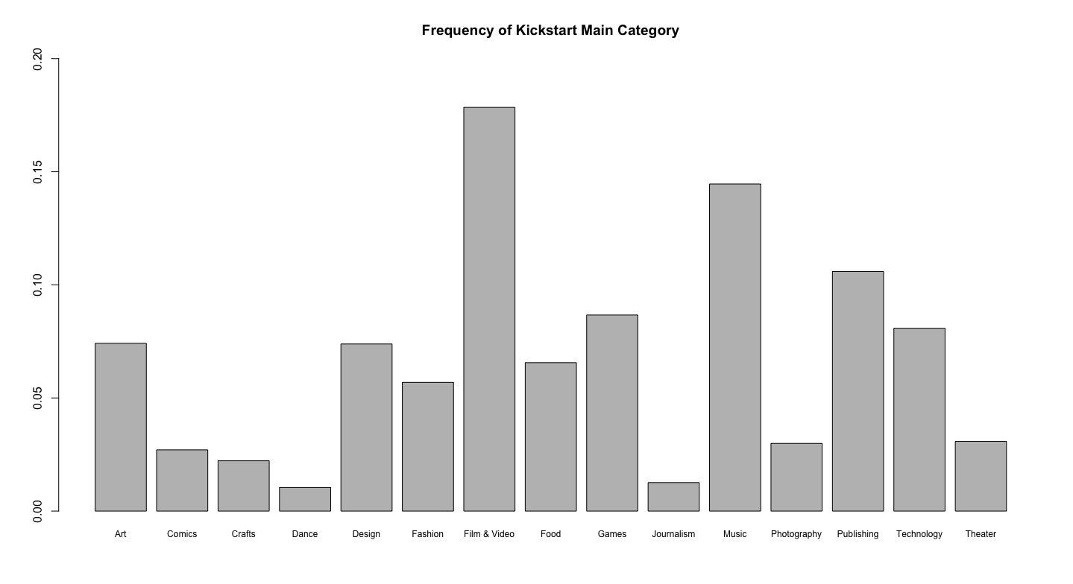

Distribution of Outcomes for all Kickstarter campaigns indicating that most fail to reach goal.

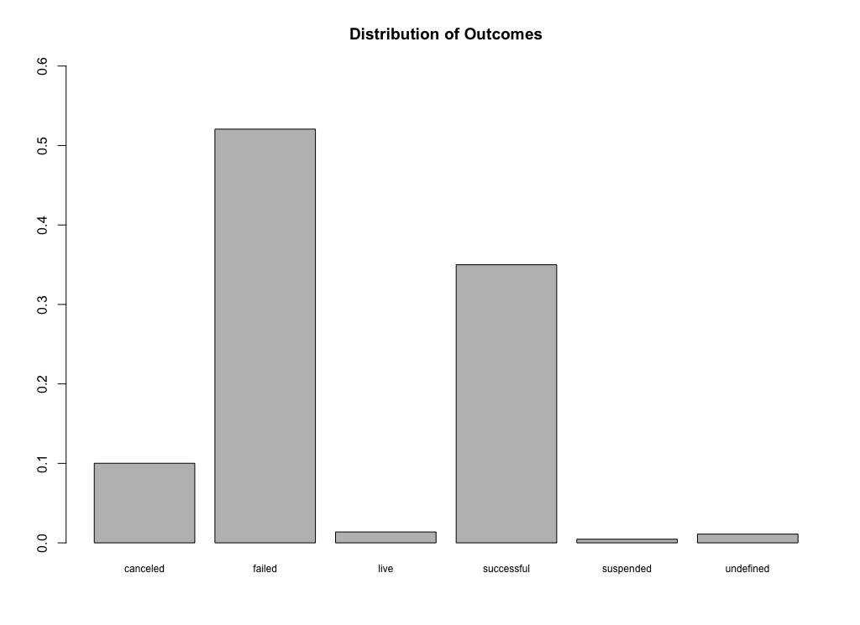

Distribution of Outcomes removing live/undefined campaigns and treating cancelled and suspended as failed still shows that most fail.

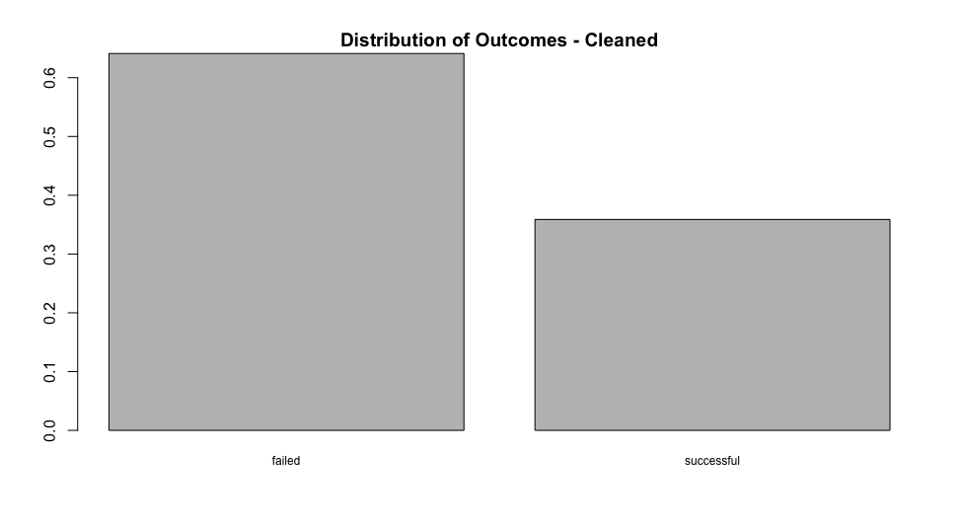

A logistic regression on potential factors that influence a campaigns chances of succeed was conducted and visualized with jtools. The effects are scaled.

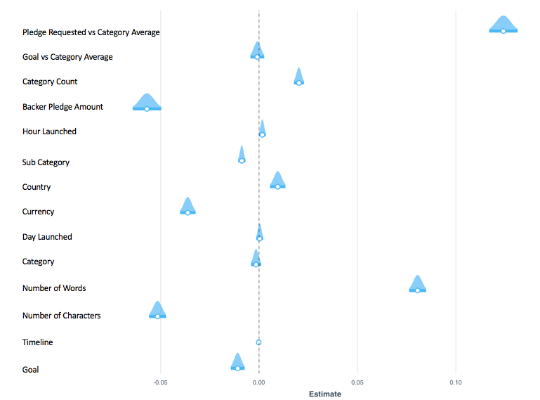

Some initial evaluation of significant (P<0.05) factors

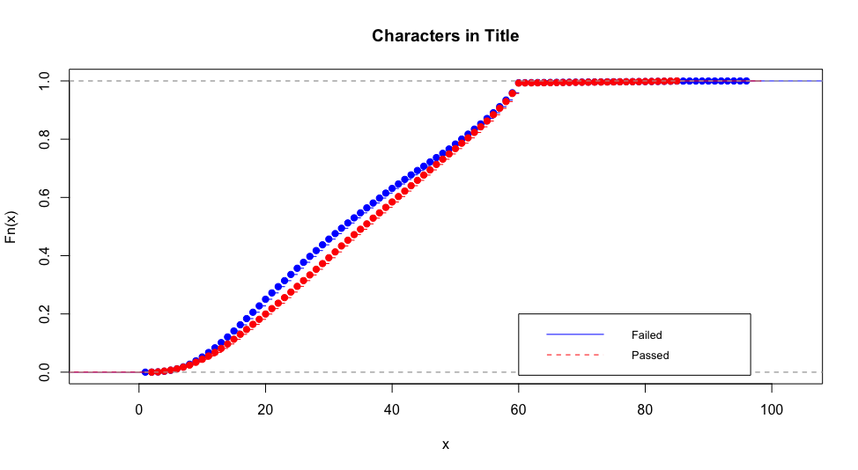

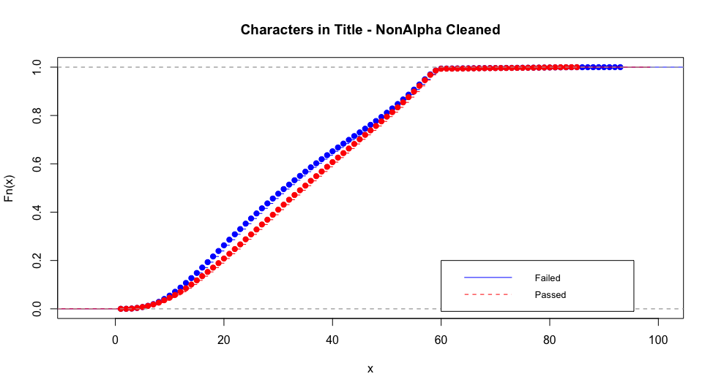

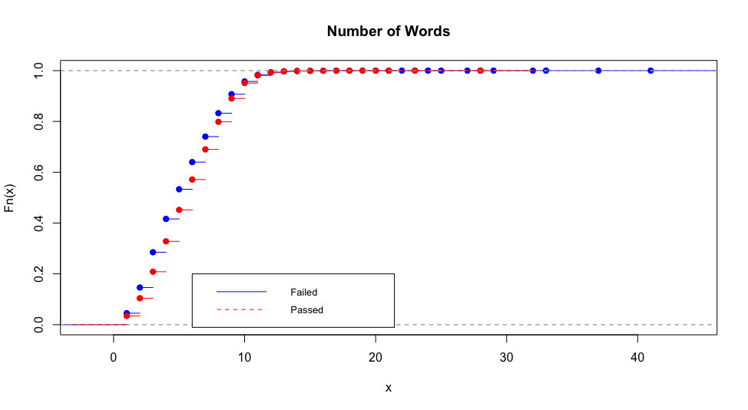

The scope was then changed to only technology projects for significant factors (P<0.05)

